**Week three, Unit 4, The Naked Truth**

**Grammar revision**

p. 30

**4.1 Question forms**

Notice these question forms:

* Subject questions with no auxiliary verb (auxiliary verb-pomoćni glagol)

**Who broke** the window?

**What happens** at the end of the book?

* Questions with prepositions at the end

**Who** is your email **from** ?

**What** are you talking **about**?

* Question words + noun/adjective/adverb

**What sort** of music do you like?

**How big** is their new house?

**How fast** does your car go?

* There are other ways of asking Why?:

**What** did you do that **for**?

**How come** you got here before us?

(How come ... ? expresses surprise. Notice that there is no inversion and no do/does/did in this question form.)

**what and which**

* What and which are used with nouns to make questions.

**What size** shoes do you take?

**Which of these curries** is the hottest?

* Sometimes there is no difference between questions with what and which.

**What/ Which** is the biggest city in your country?

**What/ Which** channel is the match on?

* We use *which* when the speaker has a limited number of choices in mind.

There's a blue one and a red one. Which do you want?

* We use *what* when the speaker is not thinking of a limited number of choices.

What car do you drive?

**Asking for descriptions**

1. What is X like? - means: Give me some information about X because I don't know anything about it.

What's your capital city like?

What are your parents like?

2. How is X? - asks about a person's health and happiness.

How's your mother these days?

3.Sometimes both questions are possible. **What ... like? asks for objective information**. **How ... ? asks for a more personal reaction.**

'What was the party like?' 'Noisy. Lots of people. It went on till three.

'How was the party?' 'Brilliant. I danced all night. Met loads of great people:

How was your journey?

How's your new job?

Hows your meal?

**Indirect questions**

* **There is no inversion and no do/does/did in indirect questions.**

I wonder what she is doing. *~~I wander what is she doing .~~

I don't know where he lives. *~~I don't know where does she live~~.

Tell me when the train leaves. * ~~Tell me when does the train leave.~~

I didn't understand what she was saying. *~~I didn't understand what was she saying~~.

I've no idea why he went to India. *~~I've no idea why did he go to India.~~

I'm not sure where they live. *~~I'm not sure where do they live.~~

He doesn't know whether he's coming or going. *~~He doesn't know wheteher is he coming or going~~.

**4.2 Negatives**

Forming negatives

1 We make negatives by adding not/n't after the auxiliary verb. If there is no auxiliary verb, we add do/does/did.

I **haven't s**een her for ages.

It **wasn't** raining.

You **shouldn't** have gone to so much trouble.

We **don't** like big dogs.

They **didn't** want to go out.

2 The verb *have* has two forms in the present.

**I don't have** any money.

**I haven't got** any money.

(But, **in the past ... I didn't have any money**.)

3 Infinitives and -ing forms can be negative.

We decided **not to do** anything.

I like **not working**. It suits me.

4 „Not“ can go with other parts of a sentence.

Ask him, **not me**.

Buy me anything, but **not perfume**.

5 When we introduce negative ideas with verbs such as think, believe. suppose, and imagine, we make the first verb negative, not the second.

**I don't think** you're right. *~~I think you aren't right.~~

**I don't suppose** you want a game of tennis?

6 In **short answers**, the following forms are possible.

**'I think so.'**

**I believe so.'**

Are you coming?' **'I hope so**.'

**'I don't think so.'**

**I hope not.'**

**I think not** is possible. *~~I don't hope so~~ is not possible.

**Negative questions**

1 Negative questions can express various ideas.

* Haven't you finished school yet? (surprise)
* Don't you think we should wait for them? (suggestion)
* Wouldn't it be better to go tomorrow? (persuasion)
* Can't you see I'm busy? Go away! (criticism)
* Isn't it a lovely day! (exclamation)

2 In the main use of negative questions, **the speaker would normally expect a positive situation**, **but now expresses a negative situation**. **The speaker therefore is surprised**.

* Don't you like ice-cream? Everyone likes ice-cream!
* Haven't you done your homework yet? What have you been doing?

3 Negative questions can also be used to mean „**confirm what I think is true“**. In this use it refers to a positive situation.

* Haven't I met you somewhere before? (I'm sure I have.)
* Didn't we speak about this yesterday? (I'm sure we did.)

4 The difference between the two uses can be seen clearly if we change them into sentences with question tags.

* You haven't done your homework yet, have you? (negative sentence, positive tag)
* We've met before, haven't we? (positive sentence, negative tag)

Practice

* Do exercises 1 and 2 in your Student's book (Test your Grammar)
* Look at the pictures on page 30. All of the pictures illustrate situations when people aren't telling the truth for some reason. Then, read the text bellow and find out what the people in the pictures are actually thinking. After reading, do exercise 3 and 4. and answer to the Language focus section (p.31)

4.1

1. Oh dear! It's not that I dislike him, I just don't love him. How can I teU him I don't want to marry him without hurting his feelings? Trouble is I actually fancy his best friend!

2. There's this group of lads you see - they're always chasing me and I don't think it's for fun. But I can't tell my mum and dad - if they find out they'll go to the head teacher and complain and that would make everything much worse.

3 How do you tell someone when they look awful? That dress doesn't suit her at all. But I don't know how to tell her, she obviously thinks she looks great in it.

4 Me and Emma are going clubbing, but I daren't tell my dad - he'd kill me. I've got an important

exam next week and I haven't done a thing for it. I haven't a clue when I'll be back.

5 J know I'm not really ill. But it's a beautiful day and I don't want to sit in a stuffy office all

day. I'm off to play golf. I never have days off usually.

6 I don't care who it is. I had a late night and I feel really rough this morning. I don't want to

be disturbed by anybody at the moment even if it is urgent.

Negatives, p.31, Do exercises 2 and 3 in your Student's book

My manic friend Milton

Do exercises 4, 5, 6, 7, 8, p.32

Read the following texts in order to complete exercise 5 and 6:

4.4

Part one

My mate Milton is a funny guy. He's an insomniac, he's dyslexic, and he's an atheist. He's single, unemployed, and lives alt alone in a tiny one-roomed flat without even a pet for company. Also, he's vegetarian and teetotal. He's pretty antisocial, actually.

4.6.

Part two

I went round to see Milton last Sunday. As I walked up the drive, his dog started barking. His wife answered the door, and she called for Milton to come downstairs and join us in the living room. He was in a bad mood because he had overslept that morning and had been late for church. He also had a bit of a hangover, which he told me was the result of a wild party that they'd had at his house the night before. They'd had a barbeque in the garden with steaks and burgers. One of his favourite pastimes is doing crosswords, and he spends every lunch break at work doing them.

'So how are you, Milton?' I asked him.

'KO, mate, KO. How about you?'

Anyway, as I said, Milton's an insomniac, dyslexic, atheist. So the joke is that he lies awake all night wondering about the existence of dog. Get it?

Key to exercises, Unit 4

Week 3

Test your grammar, p.30

1. 
2. 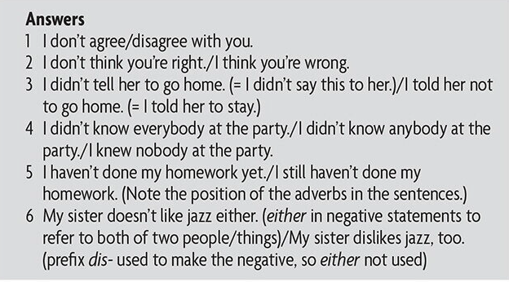

Telling lies, p.31

1. 
2. 

Language focus



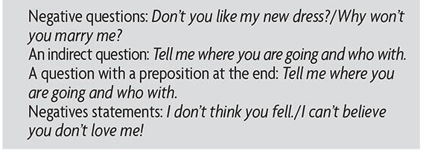

My manic mate, Milton, p.32

4.

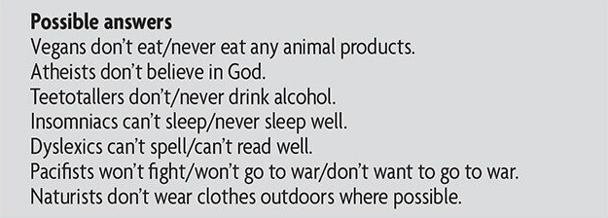

1. 
2. 
3. 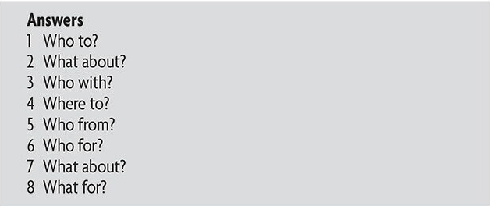
4. 